Curriculum Vitae
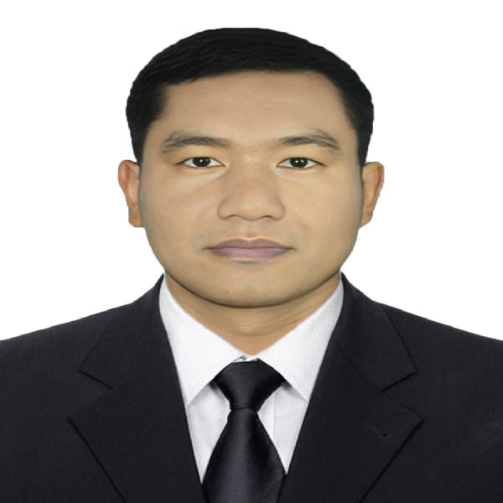

Odhir Chandro
C/O : Rabindro Nath Roy
Contact no. : +8801719286574
E-Mail : odhirroy3200@gmail.com
Github : https://github.com/Odhir2000
Linkedin :
Fiverr : https://www.fiverr.com/odhir2000
Career Objective
I am looking a hard and challenging job where I will have the scope to utilize my knowledge and skills for the development of the institution. I believe I will perform any task honestly as my goal.
Academic Qualification
Started from most recent degree:

- Name of Degree: Higher Secondary Certificate (H.S.C)
Name of Institution : Taraganj College
Board : Dinajpur
Discipline : Science
Result : GPA 3.42 in the scale of 5.00
Passing Year : 2018

- Name of Degree: Secondary School Certificate (S.S.C)
Name of Institution : Taraganj Walkf Estate High School
Board : Dinajpur
Discipline : Science
Result : GPA 4.28 in the scale of 5.00
Passing Year : 2016

Computer Knowledge
- Operational System : Windows XP, Windows 10
- Database Languages : MS Office.

Language Skills
- Bengali : Mother Tongue.
- English : Reading, Writing and Speaking fluently.

Strength
- Patient, honesty and positivism.
- Creative thinking, dedication and hard working.
- Self motivated and strong concern for career.
- Good leadership skill.

Training
- Training Course on “Computer Office Aplication” Department Of Youth Development, Nilphamari. Duration: 6 Months.
- Computer Fundamentals and Office Applications Training
Organized by Bangladesh Computer Council and Center for Digital Transformation (CDT), Begum Rokeya University, Rangpur
Funded by Enhancing Digital Government & Economy (EDGE) Project
Year of Completion - 2025
- Gained proficiency in basic computer operations and Microsoft Office applications.
- Hands-on experience with tools like Word, Excel, PowerPoint, and others.
- Learned essential skills for digital government services and economic applications.

Technical Skills
- Office Applications: Microsoft Word, Excel, PowerPoint
- Computer Fundamentals: Hardware and software basics, troubleshooting
- Proficient in Microsoft Office Suite (Word, Excel, PowerPoint, Outlook)
- Basic computer troubleshooting
- Understanding of digital government services
- Strong attention to detail and organizational skills
- Excellent communication and teamwork abilities
Projects

- Academic Marksheet
- I make an academic mark-sheet using MS Office 2016.

- Salary Sheet
- I make an academic mark-sheet using MS Office Excel 2016.

- Hostel Maintenance Sheet
- I make a Hostel Maintenance Sheet using MS Office Excel 2016

- Biography Presentation
- I make a biography presentation using MS Office PowerPoint 2016

Certifications
- Computer Fundamentals and Office Applications Training

Employment History
- Fresh

Personal Information
- Name : Odhir Chandro
- Father’s Name : Rabindro Nath Roy
- Mother’s Name : Rita Rani Ray
- Permanent Address : Vill – Shamganj, Post- Shamganj.
Upazila- Taragonj, Dist- Rangpur.
- Present Address : Vill – Shamganj, Post- Shamganj.
Upazila- Taraganj, Dist- Rangpur.
- Date of Birth : 02 January 2000
- Sex : Male
- Nationality : Bangladeshi (By birth)
- Blood Group : AB ^{(ve+)}
- Height : 5 feet 5 inch.
- Marital Status : Single
- Religion : Hinduism
- National ID No : 2414370896

Reference

Reference: 01
Name - Md Yousuf Ali
Organization - Nilphamari Govt College
Designation - Lecturer Of ICT

Reference: 02
Name - Md. Jahangir Alam
Organization - Nilphamari Govt College
Designation - Associate Professor Of Chemistry

Declaration
I hereby, declare that the above information in the resume is true and correct to the best of my knowledge and behalf.

(Odhir Chandro)

Date:

